1.5 Surface Area Worksheet

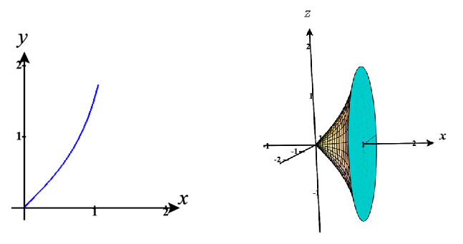
- Setup, but do not evaluate, an integral for the surface area of the surface obtained by rotating on about the…
- x-axis (setup integral with respect to x and y)
Respect to x: Note that is non-negative on and is continuous on Therefore, the surface area is given by .
Respect to y: First note that is one-to-one on and this interval is within the range of the inverse tangent function, and so we can use the inverse tangent function here to solve this equation for x. on .
Note that is non-negative on and is continuous on .
Therefore, the surface area is given by
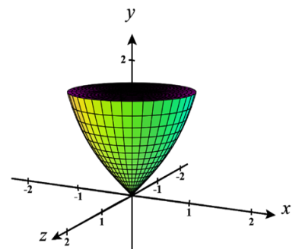
- y-axis (setup integrals with respect to x and y)
Respect to y: As noted above we can solve this equation for x. on . Note that is non-negative on and is continuous on .
Therefore, the surface area is given by
Respect to x: Note is non-negative on and is continuous on .
Therefore, the surface area is given by
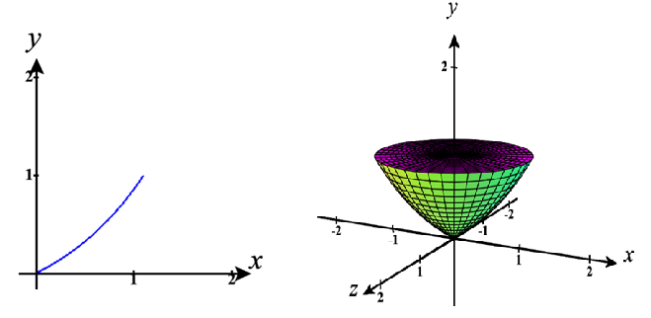
- Setup, but do not evaluate, an integral for the surface area of the surface obtained by rotating on about the…
- y-axis (create integrals with respect to x and y.
Respect to y: Note that is non-negative on and is continuous on .
Therefore, the surface area is given by .
Respect to x: We first solve the given equation for y.
on .
Note that is non-negative on and is continuous on .
Therefore, the surface area is given by .
- x-axis
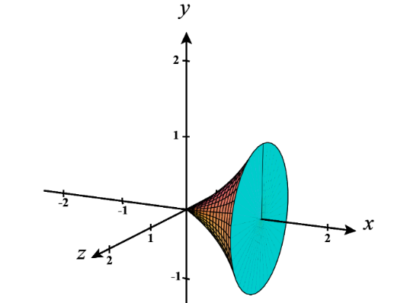
Respect to x: We first solve the given equation for y. on Note that is non-negative on and is continuous on .
Therefore, the surface area is given by .
Respect to y: Note that is non-negative on and is continuous on .
Therefore, the surface area is given by .
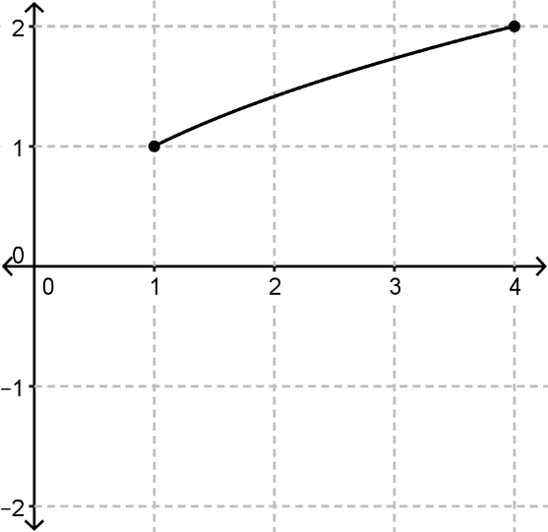
- Find the surface area of the solid generated by revolving the curve , about the x-axis. Set up integrals with respect to x and y and then evaluate one of them.
Respect to x:
We note that is non-negative on the interval and is continuous on the interval .
Therefore the surface area of the solid is given by:
We calculate the surface area to be the following.
Respect to y:
We solve the given equation for x: , where y ranges from to .
We note that is non-negative from to and is continuous from to .
Therefore the surface area of the solid is given by:
We calculate the surface area to be the following.
Let this implies that . Our bounds change to
.
Therefore we have:
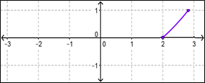
- Find the surface area of the solid generated by revolving the curve , about the
y-axis. Set up integrals with respect to x and y and then evaluate one of them.

Respect to y:
We note that is non-negative on the for and is continuous for .
Therefore the surface area of the solid is given by:
We calculate the surface area to be the following.
Respect to x:
We solve the given equation for y: , where .
We note that is non-negative for and is continuous for .
Therefore the surface area of the solid is given by:
Let this implies that . Our bounds change to
.
Therefore we have:

- Consider the curve on the interval and the resulting surface when this curve is rotated about the y-axis. Setup and evaluate, an integral that represents the surface area of this surface.
- Setup and evaluate the integral with respect to y.
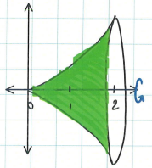
We first note that .
We see that is non-negative on and is continuous on .
Therefore, the surface area is given by .
Let this implies that . Our bounds change to
.
Therefore we have:

- Setup the integral with respect to x.
We see that the portion of the curve that we are working with exists on the interval .
Note that is continuous on , however is NOT continuous on (specifically at ). Therefore we cannot guarantee that the surface area formula works here and we cannot continue.

- Find the surface area of the solid generated by revolving on about the y-axis.
We start by solving the given equation for x. , where y ranges from 0 to 4.
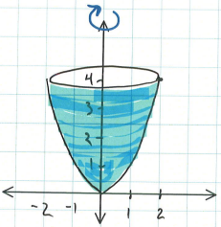
We note that is non-negative from to and is NOT continuous from to (specifically at ). Therefore we cannot set up this integral with respect to y. We will instead set up an integral with respect to x.
We note that is continuous on and is continuous on
Therefore the surface area of the solid is given by:
We calculate the surface area to be the following.

- Consider the curve on the interval and the resulting surface when this curve is rotated about the x-axis. Setup, but to not evaluate, an integral that represents the surface area of this surface.
- Setup the integral with respect to x.
We note that is non-negative on and is continuous on .
Therefore, the surface area is given by
- Explain why setting up this integral with respect to y would be very difficult.
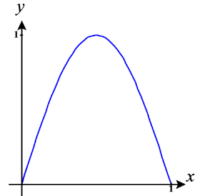
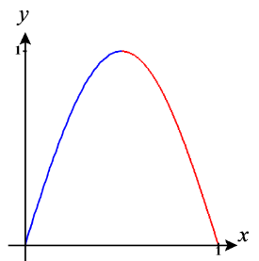
In order to start integrating with respect to y we would have to solve the equation for x. However, on the interval we note that is not one-to-one and so solving for x isn’t possible with a single equation. Therefore, we would instead have to create two different equations and then create two different surface area integrals with respect to y.

